9,5 or 23,75/25

R Computer Lab #2

Helga Hafdís Gunnarsdóttir

Question 1 - Item Response Functions and Person Estimates

1. a) Item 10 is hardest and item 5 is easiest. 2
2. -1.63 +/- 1,96*0,13 = -1,8848 / -1,3752. With 95% confident we can say that true item difficulty for the easiest item lies between -1,88 and -1,38 (-.5) 1.5

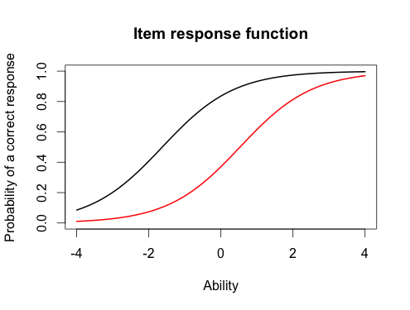

c) Item 5 is the red line and item 10 is the black line. 1

1. The probability of a correct response would be around 0,3 for the hardeast item and the probability of a correct response would be around 0,9 for the easiest item. 2
2. The score of the person who did best on the test was 3,99 and the score of the person that did worst on the test was -3,99 2
3. I can say with 95% confidence that the true ability (-.5) for the person who scored best on the test lies between -0,31 (-.25) and 8,29 1.25

(3,99 +/- 1,96 *2.2)

est_abl[49,]

est sem n

49 3.999921 2.204373 18

est_abl[393,]

est sem n

393 -3.999947 1.225286 18

Estimated Parameters

> #

> est_params <- rasch_model$est

> colnames(est_params) <- c("Discrimination", "Difficulty", "Guessing")

> rownames(est_params) <- paste("Item", 1:18)

> est_params

Discrimination Difficulty Guessing

Item 1 1 -1.40938612 0

Item 2 1 -0.35055656 0

Item 3 1 -0.90318970 0

Item 4 1 -0.97412011 0

Item 5 1 -1.62671110 0

Item 6 1 0.02533657 0

Item 7 1 -0.41418545 0

Item 8 1 -0.87993298 0

Item 9 1 -0.91498121 0

Item 10 1 0.52959427 0

Item 11 1 -1.17125435 0

Item 12 1 -0.04749604 0

Item 13 1 0.15008663 0

Item 14 1 -0.74253017 0

Item 15 1 -0.74245332 0

Item 16 1 0.36963876 0

Item 17 1 -0.84513136 0

Item 18 1 -1.45145349 0

* 1#

plot(irf(est_params[c(5,10),]), co = NA) to do the plot

Discrimination SE Difficulty SE Guessing SE

Item 1 NA 0.1267448 0

Item 2 NA 0.1128011 0

Item 3 NA 0.1178581 0

Item 4 NA 0.1188426 0

Item 5 NA 0.1320051 0

Item 6 NA 0.1118476 0

Item 7 NA 0.1131572 0

Item 8 NA 0.1175527 0

Item 9 NA 0.1180162 0

Item 10 NA 0.1136598 0

Item 11 NA 0.1220123 0

Item 12 NA 0.1118797 0

Item 13 NA 0.1119630 0

Item 14 NA 0.1159197 0

Item 15 NA 0.1159189 0

Item 16 NA 0.1126941 0

Item 17 NA 0.1171115 0

Item 18 NA 0.1276902 0

Question 2 – Information

1. I choose item 1, 3 and 5 1
2. 1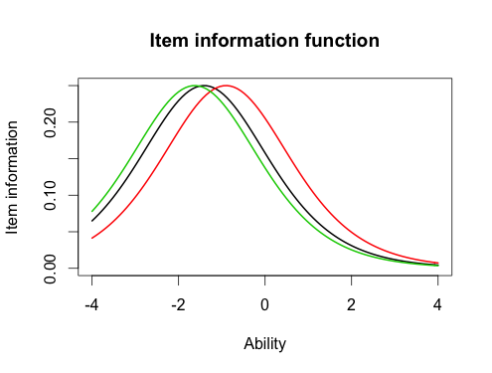
3. What is the same is that the shape is the same, and the peaks are equally high, but the the items are located differently. 2
4. 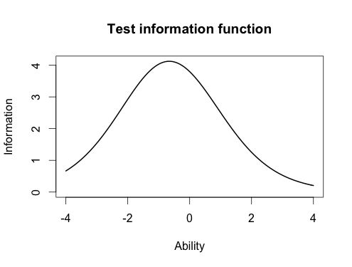

1

e) The marjority of the information is located at -1,0 1

plot(iif(twopl_params[c(1,3,5),]), co = NA)

Question 3 - Comparing the 2-PL

1. Item 8 had the highest discrimation and item 12 had the lowest discrimination 2
2. In the Rash model, item 5 is the easiest and item 10 is the hardest. In the 2 pl model item 1 is the easiest and item 10 is the hardest. So the answear is NO. 2
3. The correlation between the ability estimates and on the Rasch model and the 2 pl is 0,9 and that is very high correlation. I would draw the same conclusion from both models because the correlation between the to are so high. So that means that person that had high score in Rasch would also have high scores in the 2pl. 2

d) 1

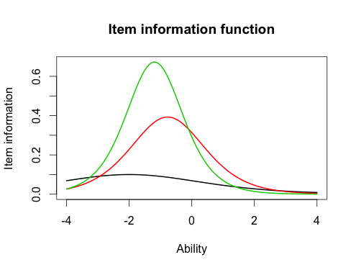

1. The main difference between these items is the item discrimination as item 5 has the highest discrimination, that means that is has more information at the item location than the other items. Item 1 has the lowest discrimination and item 3 is in the middle of these two items. The shape of these items is also different, the green line is the steepest and the black line is the least steepest, and the red one is in the middle. When the discrimination is high, the higher is the peek is the picture. In the 2pl model we don´t have any information about item 1 but we have a better information about item 3 and 5. But in the Rasch model we have good information about all of the items. Because the shapes are the same because they have the same discrimination.

2

Green line : Item 5

Red line : Item 3

Black line : item 1

Discrimination Difficulty Guessing

Item 1 0.6326689 -2.00058101 0

Item 2 1.5469622 -0.26815483 0

Item 3 1.2534918 -0.77297206 0

Item 4 0.9842598 -0.97706755 0

Item 5 1.6407242 -1.19389580 0

Item 6 1.4702029 0.01833431 0

Item 7 0.5632837 -0.65124651 0

Item 8 2.2881772 -0.56753253 0

Item 9 1.8004066 -0.64761748 0

Item 10 1.1142107 0.48542889 0

Item 11 1.0344119 -1.13363005 0

Item 12 0.3329130 -0.12951933 0

Item 13 0.3369968 0.36344671 0

Item 14 0.6608229 -1.01479867 0

Item 15 1.5980393 -0.55640285 0

Item 16 1.0362116 0.35459121 0

Item 17 1.8591845 -0.59017915 0

Item 18 1.2808752 -1.22177042 0

# Correlation between the ability estimates

> cor(twopl_abl$est,est_abl$est)

[1] 0.9709497

plot(iif(twopl_params[c(1,3,5),]), co = NA)